**Step 1:**

Type fast2sms in google and click on the fist link

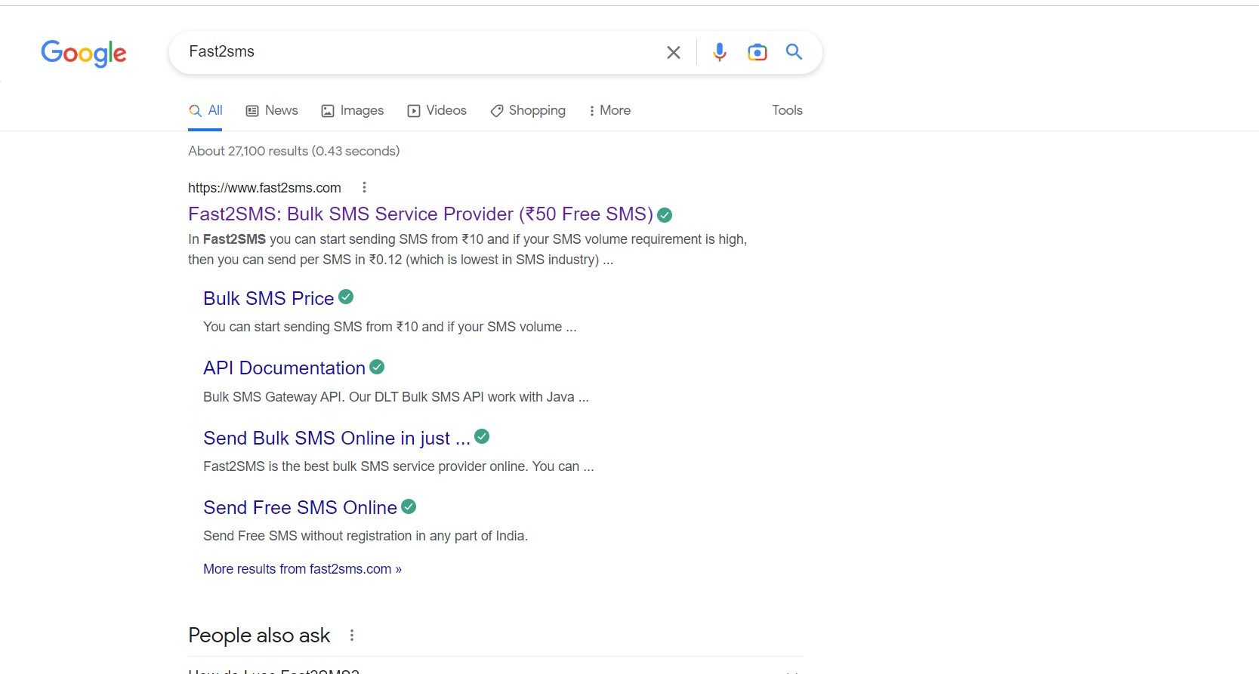

**Step 2:**

click on sign up now

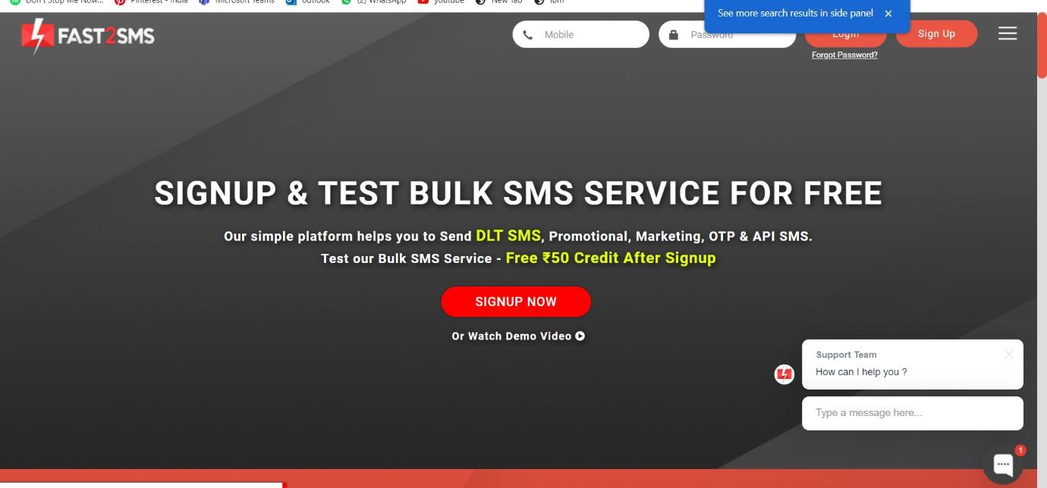

**Step 3:**

Give your details and click on the check box, then click the submit button.

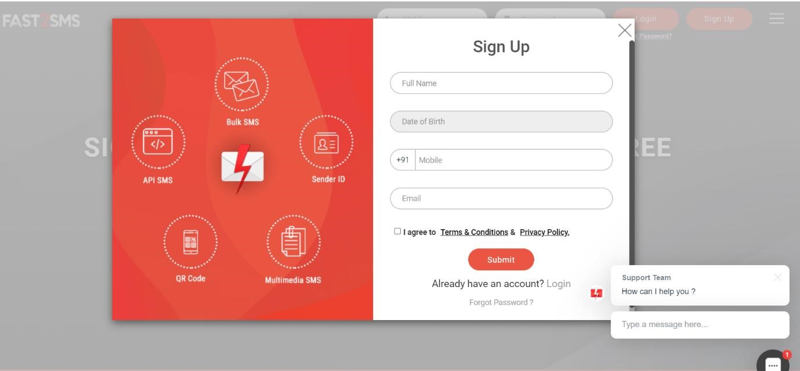

**Step 4:**

You will get the SMS with your password. Type your mobile number and the password then click on the submit button.

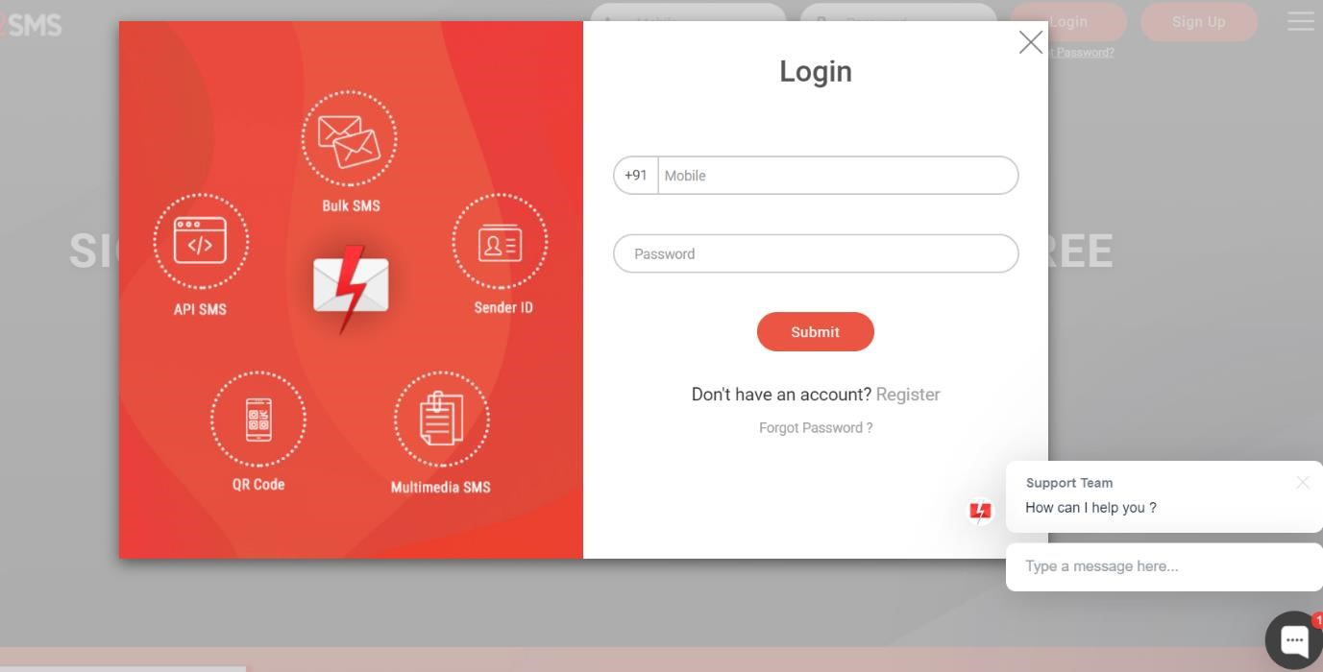

**Step 5:**

Click on the Dev API

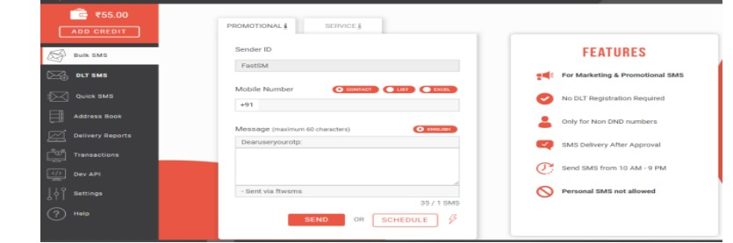

**Step 6:**

Select the Route as Quick SMS and type the message in Message box.

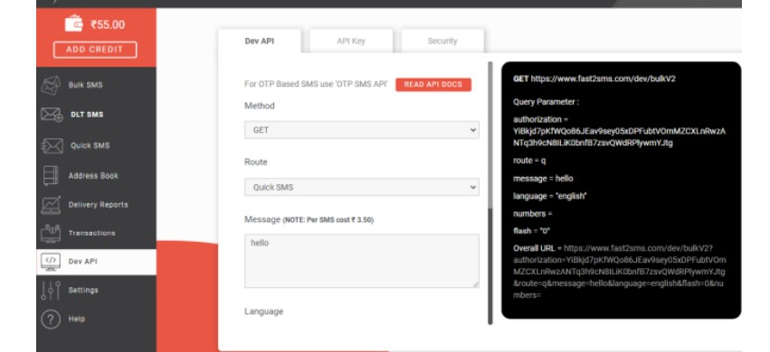

**Step 7:**

Select your language and type your Mobile number in contact

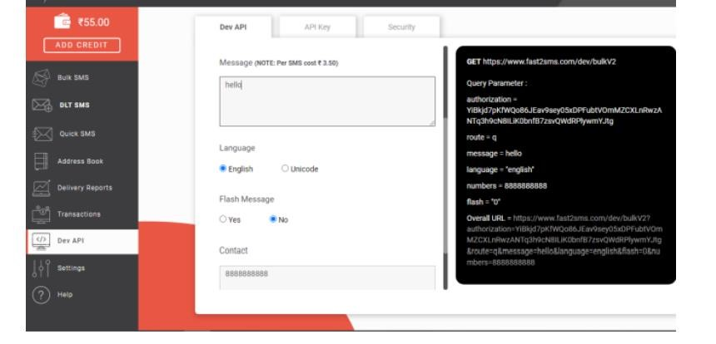

**Step 8:**

Copy the URL and paste it in the new tab

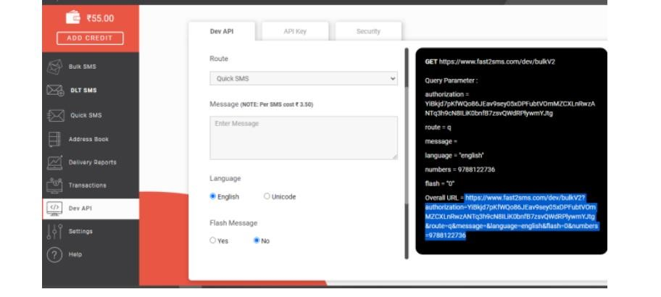

**Step 9:**

You will get the SMS in the new tab

